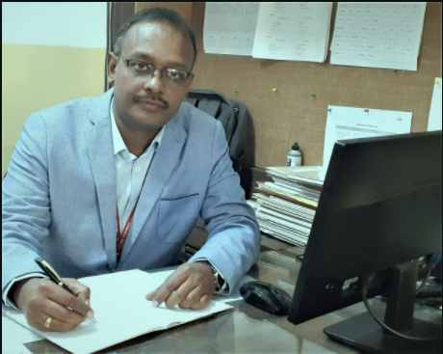

**"Learning is lifelong - Lifelong is the learning"**

**Dear Students,**

**Greetings from Paul Classes!**

**The word “LIFE” itself means “Learning is forever”, and it’s my pleasure to welcome you all to Paul Class. The motto of Paul Class is "Learning is lifelong - Lifelong is the learning".**

**It was my dream to reach out to the masses to provide a Joyful Learning Experience of teaching and learning the subject Mathematics in an easy and lucid manner. The present pandemic made it possible through the online classes conducted by Paul Class.**

**Due to the present pandemic situation the online classes conducted by Paul Classes has provided an opportunity to reach out to the maximum students across the country, and to have an easy access to interact with them in the learning of mathematics in an easy way.**

**At Paul Classes we provide personalized coaching to the students in the subjects given below:-**

* **CLASSES IX & X: - Physics, Chemistry & Mathematics.**
* **CLASSES XI & XII: - Applied and Standard Mathematics.**

**Request to login to our registration portal for more details.**

**With Best Wishes**

**C Paul Verghese**